How to copy specific no of files with different names not having same pattern in another adls

Gdgd.txt

Rwtw.txt

Sfsf.txt

Fsf.txt

1. add these file names in a specific file in the source folder
2. then go to azure data factory create datasets and linked services normally
3. create copy activity
4. go to source selct dataset
5. then go to file list below

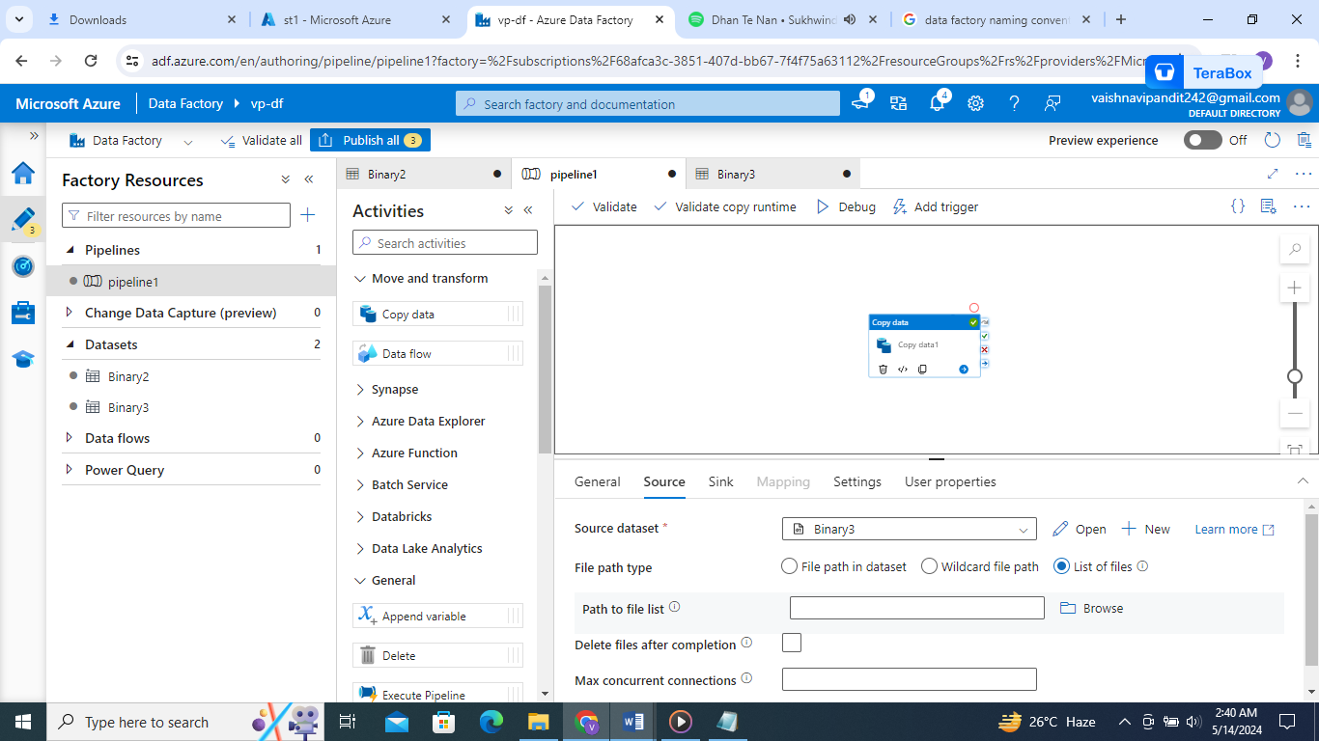

1. avoid mistake while saving the file of filnames don’t gave space after name and the cursor.
2. Add the filename of the list of files

